Assignment 1 and 2
Assignment 1
import torch
print(torch.cuda.is_available())
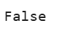
Assignment 2
import numpy as np

# Create random matrix
rows = 20000
cols = 10000

data = np.random.rand(rows, cols)

# Save to file
np.savetxt("large_data.txt", data)

print("File created successfully!")
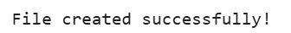
#Assign Subsequent Rows to First Row Elements
import numpy as np

# Example small matrix
matrix = np.random.randint(1, 10, (5, 5))
print("Original Matrix:\n", matrix)

first_row = matrix[0]

# Assign subsequent rows using first row
for i in range(1, matrix.shape[0]):
matrix[i] = matrix[i] + first_row

print("Updated Matrix:\n", matrix)
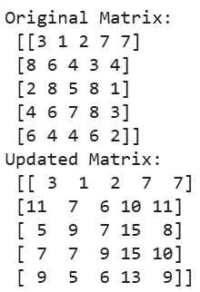
#Group Similar Elements into Matrix
import numpy as np

matrix = np.random.randint(1, 5, (5, 5))
print("Matrix:\n", matrix)

unique, counts = np.unique(matrix, return_counts=True)

print("Grouped Elements:")
for u, c in zip(unique, counts):
print("Value:", u, "Count:", c)
